The purpose of this task was to gain hands-on experience configuring a Windows Server to host web services using Internet Information Services (IIS). This included assigning a static IP address, installing the IIS role, and deploying a simple static HTML page to verify web server functionality. The objective was to understand how web services operate in a Windows environment and validate accessibility via a web browser using both the server's hostname and IP address.

https://learn.microsoft.com/en-us/iis/manage/creating-websites/scenario-build-a-static-website-on-iis

1. Configure your Windows Server virtual machine with the specifications identified in the

document titled “Specifications for ITNW-2354 Labs.pdf”

• Active Directory is not required for this module (no domain name, FQDN, DSRM, or WinUsers in

this module)

Password changed in accordance with Specification Document Admin: Password1

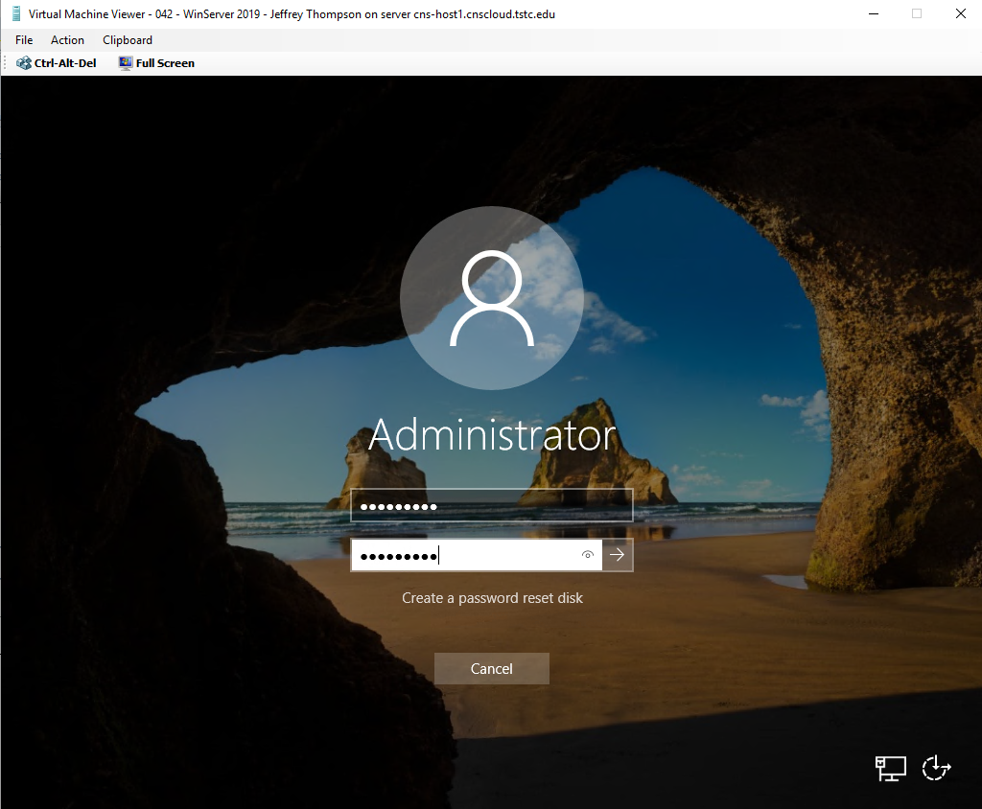

2. Configure the correct date, time and time zone (appropriate for Central Texas)

1. **Adjust Date/Time**
   * Right-click taskbar
   * Select adjust date/time

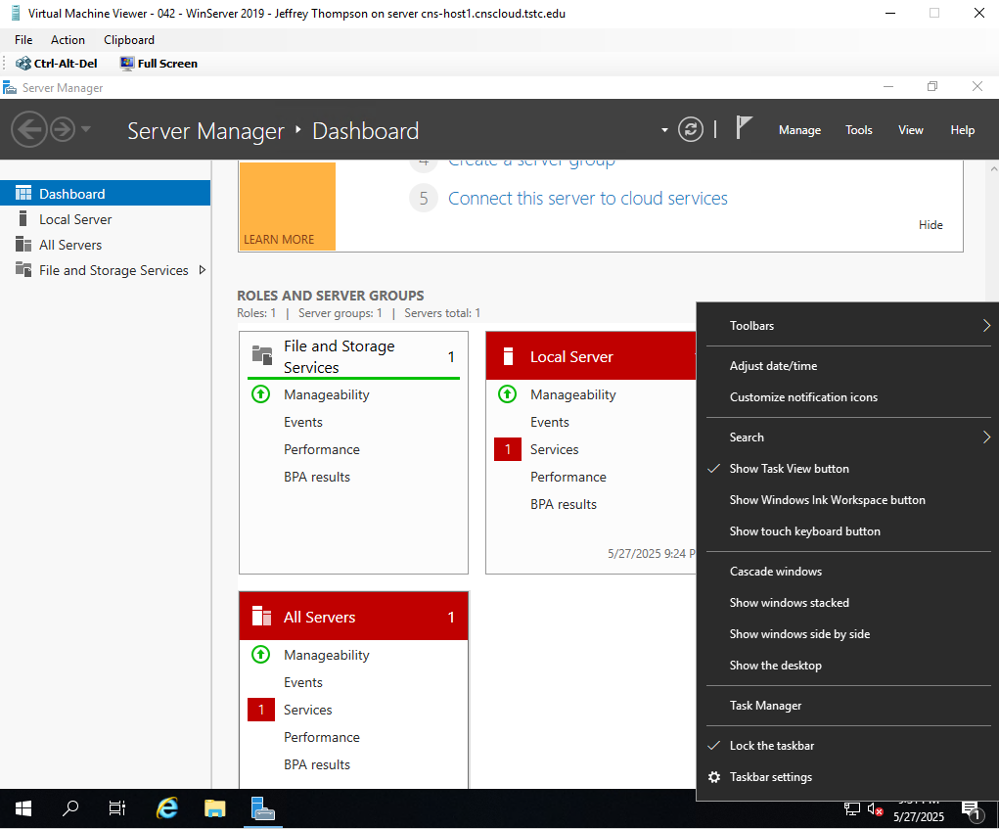

1. **Set Time Zone for appropriate region**

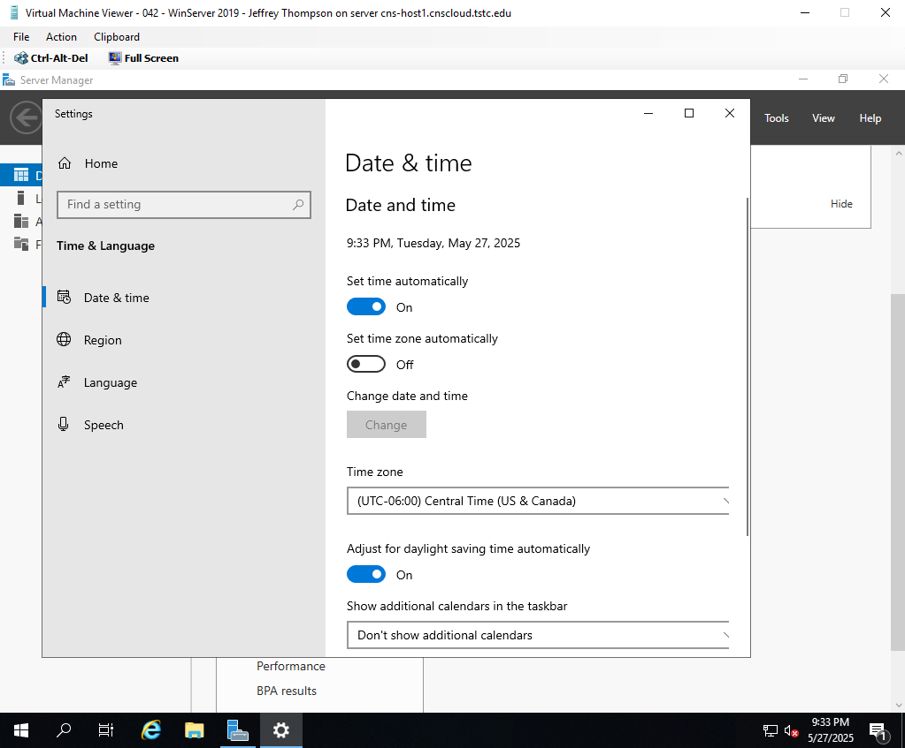

3. Statically configure the TCP/IP settings as identified in the document titled

“Specifications for ITNW-2354 Labs.pdf” (TCP/IP settings are subject to change per semester)

1. **Open Network Settings**:
   * Right-Click Network Icon
   * Select Open Network & Internet Settings.

1. **Right-click your active network adapter**:
   * Click Change adapter options.

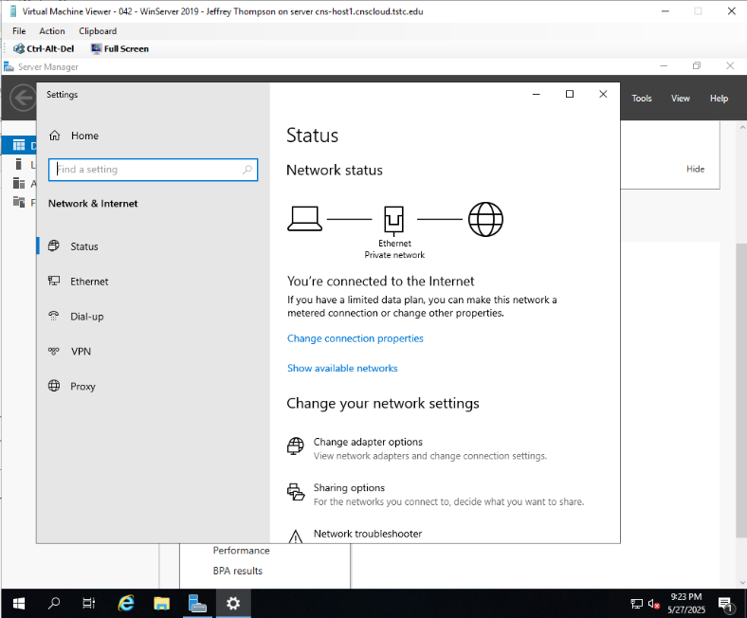

* + Right-Click the adapter option you want to change in this case “Ethernet”
  + Click **Properties**.

1. **Select “Internet Protocol Version 4 (TCP/IPv4)”**:
   * Click **Properties** below the list.

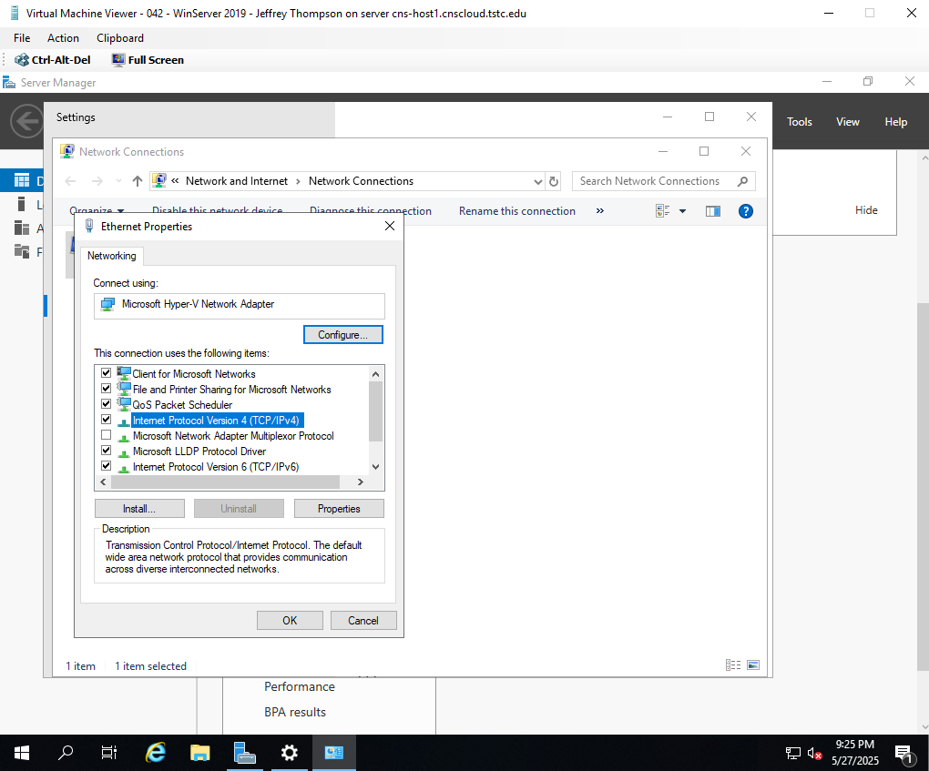

1. **Set Static IP**:
   * Select **Use the following IP address**.
     + **IP address**: 172.16.154.42
     + **Subnet mask**: 255.255.0.0
     + **Default gateway**: 172.16.0.1
2. **Set DNS Servers**:
   * Select **Use the following DNS server addresses**:
     + Preferred DNS: 172.16.0.1
     + Alternate DNS:
3. **Click OK** to close each dialog box.

1. **Verify the settings**:
   * Open **Command Prompt** and type: ipconfig /all

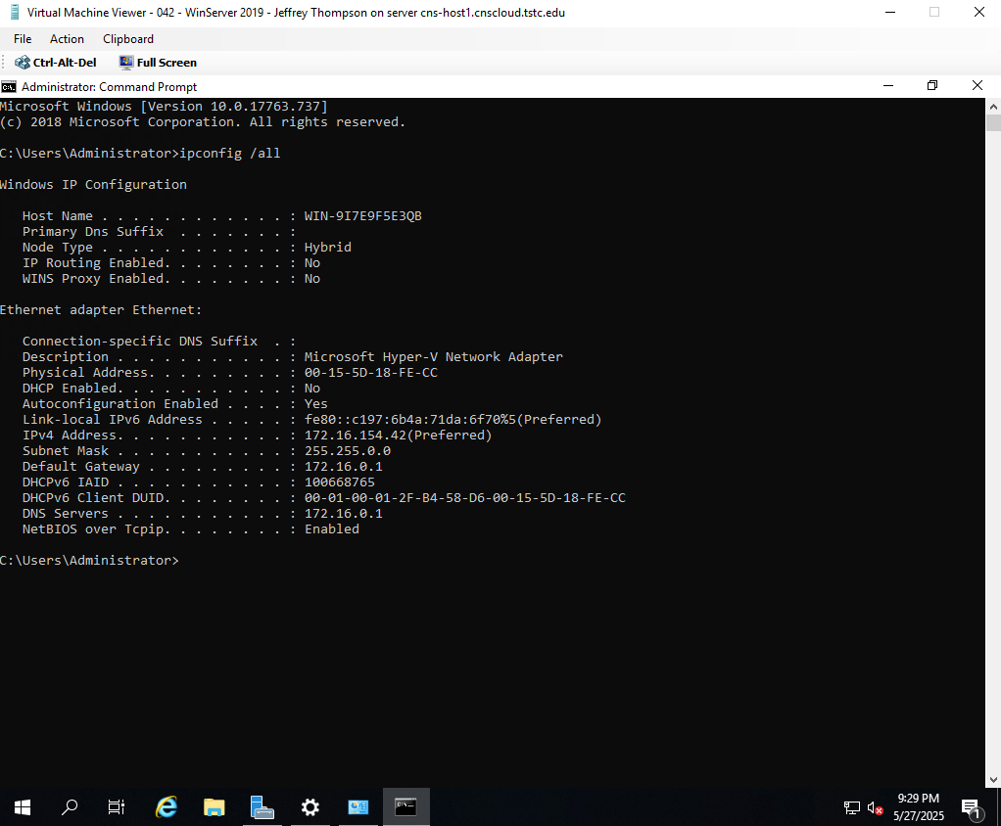

4. Install Internet Information Services (IIS) on your Windows Server

**1. Add Roles and Features**

* + Click the manage drop-down menu
  + Select Add Roles and Features

1. **Install ISS**
   * Before you begin select next

* Installation Type – select Role-Based or feature-based installation
* Click Next

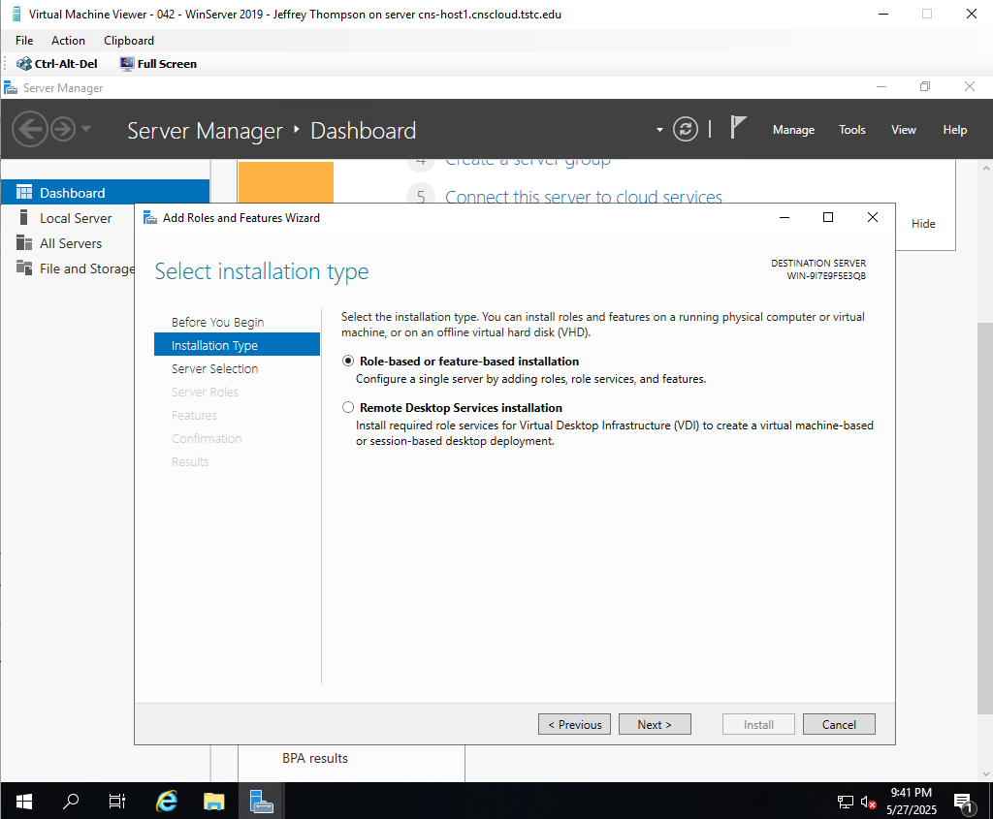

* Server Selection
* Select server from the server pool

* Server Roles – Select Web Server (IIS)

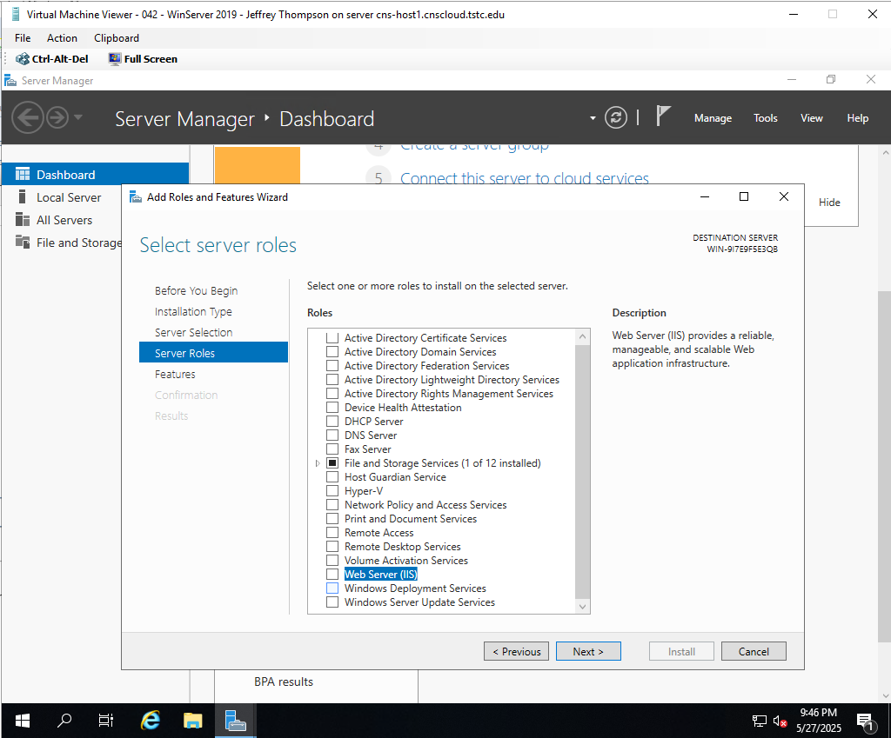

* Select add features that are required for Web Server (IIS)
* Select next on the server roles screen

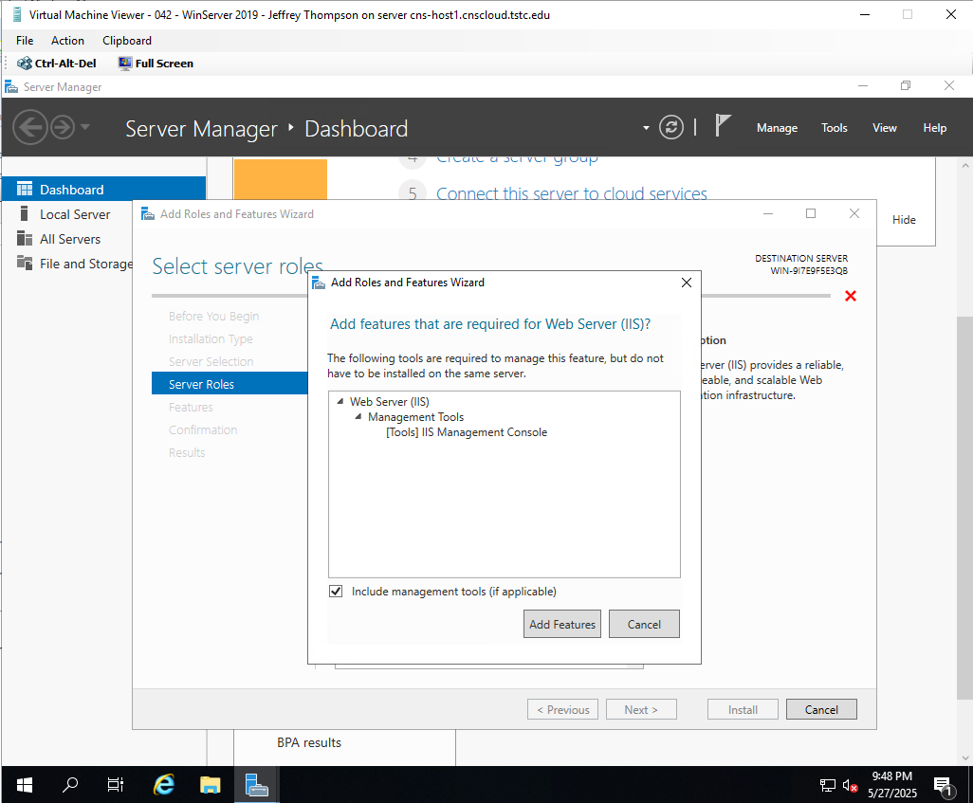

* Select next on the server roles screen

* Select next on the Select features screen

* Select Next on the Web Server Role (IIS) Screen

* Select Next on the Role Services Screen

* Check the box marked Restart the destination server automatically if required
* Select Install on the Confirmation Screen

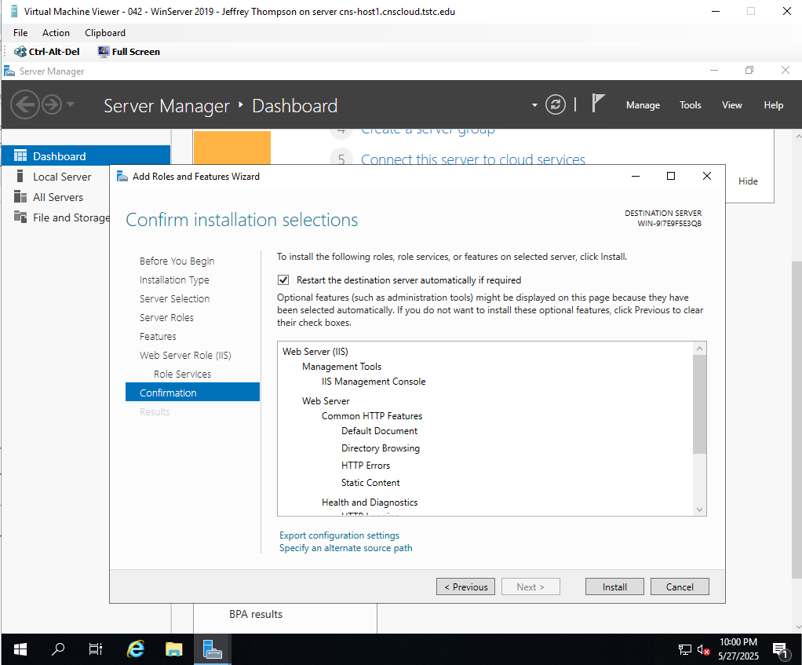

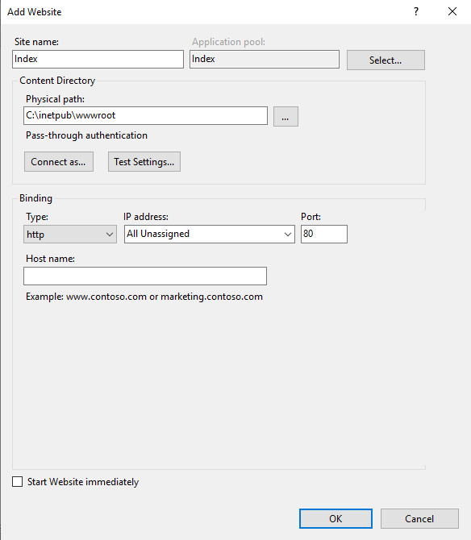

5. Create a basic “Index.htm” file using HTML code that will display a web page that says

“Hello Windows World”

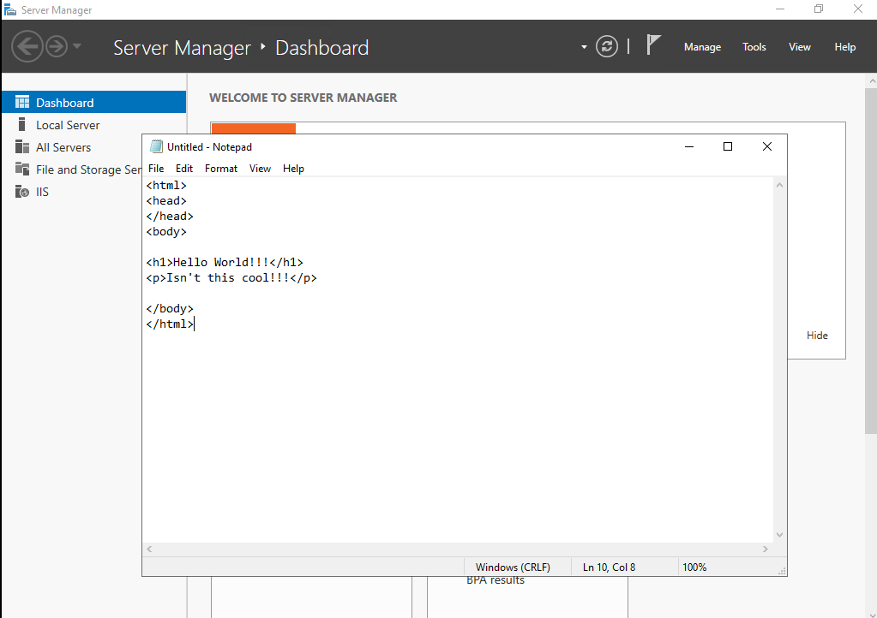

<html>

<head>

</head>

<body>

<h1>Hello World!!!</h1>

<p>Isn’t this cool!!!</p>

</body>

</html>

6. Save the “Index.htm” file in the default IIS file location (DO NOT overwrite or remove

the existing files)

* File “Save as” on the note pad doc.
* Save as index.htm
* Change file type to all types
* Save in the in the C: \inetpub\wwwroot folder

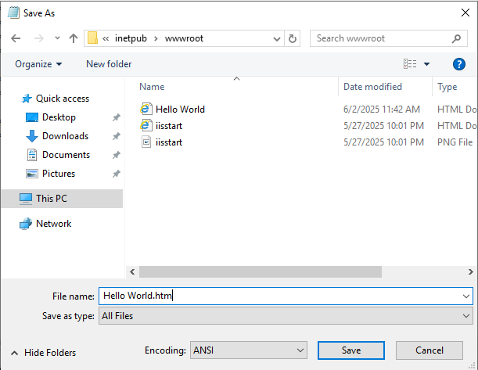

7. Using a browser on your server, navigate to your new default web site on your Windows

Server by entering your server URL in the address bar.



The Windows Server web host was successfully configured with a static IP address, and the Internet Information Services (IIS) role was installed. A custom index.htm file containing a static HTML message was created and deployed to the default IIS web directory. Using a browser on the server, the site was successfully accessed via both localhost and the server’s static IP, displaying the intended “Hello Windows World” message. This confirms that IIS is properly installed and serving static content as expected.